Tier 2 Utah RISE 2.5 Recruit & Retain
Thank you for your interest in the Tier 2 RISE 2.5 Initiative, administered by the Association for Utah Community Health under Utah's Rural Health Transformation Program (RHTP).

Before You Begin
Please review the eligibility and compliance requirements below before starting your application. Applicants that do not satisfy the following eligibility and compliance requirements cannot be considered for funding. Please contact Sandra Debry at sdebry@auch.org for questions regarding eligibility.

By applying, your organization affirms and acknowledges that:
- It is a Federally Qualified Community Health Center and/or I/T/U organization operating in a rural Utah county and listed in the UDHHS RISE 2.5 RFGA I/T/U eligible list.
- It is not debarred, suspended, or otherwise excluded from participation in federal programs.
- It will comply with all applicable federal and state laws, regulations, and program requirements, including 2 CFR Part 200, the RHTP Notice of Funding Opportunity (NOFO), the Notice of Award, and RHTP Program Directives.
- It will use funds only for the purposes and activities approved in this application and any resulting sub-grant agreement.
- It will cooperate with all monitoring, reporting, and evaluation requirements, including quarterly and annual reports and site visits conducted by DHHS, CMS, and/or AUCH.
- Continued funding is contingent on satisfactory performance, timely reporting, and the availability of CMS funds.
- If funded, it will acknowledge federal funding support in all public-facing materials, as required by the Stevens Amendment.

The RISE 2.5 Recruit and Retain Initiative is supported by the Centers for Medicare & Medicaid Services (CMS) of the U.S. Department of Health and Human Services (HHS) under the Rural Health Transformation Program, through a subaward from the Utah Department of Health and Human Services to the Utah Education and Telehealth Network (UETN), as part of a financial assistance award totaling $5,766,435 with 100 percent funded by CMS/HHS. The contents are those of the author(s) and do not necessarily represent the official views of, nor an endorsement, by CMS/HHS, or the U.S. Government.

Tier 2 Sub-Award Application
This application is designed to collect the information required for AUCH and DHHS to administer funds, monitor performance, and meet CMS Rural Health Transformation Program (RHTP) reporting requirements. Eligible Tier 2 organizations are federally designated Tier 2 Subawardees providing services in a rural Utah county.

Applications Due: Submitted to Sandra Debry at sdebry@auch.org no later than midnight on September 25, 2026.

Frequently Asked Questions (FAQs): Submitted to Sandra Debry at sdebry@auch.org; last day to submit questions is September 23, 2026. FAQs are available here.

Awards will be administered through a Memorandum of Understanding (MOU) for the period beginning October 1, 2026 and ending September 30, 2027 (see Appendix C for sample MOU).

Section 1: Organization Information
Organization Name:
Physical Address:
Rural Utah County(ies) Served:

EIN/TIN:

Primary Contact
Name:
Title:
Email:
Phone:

Section 2: Eligibility Attestation
Please check each box that applies.
- We are a Federally Qualified Community Health Center operating in a rural Utah county.
- We are an I/T/U organization operating in a rural Utah county and listed as eligible in UDHHS RISE 2.5 RFGA.
- We independently bill Medicare and/or Medicaid.
- We will only support clinical staff who provide a minimum of 15 hours of direct patient care per week through this funding.
- We understand that certain recruitment and retention incentives require individual clinical staff to complete a five-year rural Utah service commitment beginning from the date of last incentive received.
- We agree to incorporate required 5-year rural Utah service commitment and repayment language into employment agreements, incentive agreements, and/or contract amendments before distributing incentive funds.
- We understand that if clinical staff receiving incentive funding leave before completing a required 5-year rural Utah service commitment, AUCH must be notified within 30 days of departure.
- We understand that if clinical staff receiving incentive funding leave before completing the required 5-year rural Utah service commitment that repayment/proration may be required based on incentive and service completed.
- If repayment/proration is required, we agree to cooperate with AUCH in recouping the money within six months of the clinical staff’s departure.
- We agree to comply with all CMS, DHHS, and AUCH reporting, monitoring, and record-retention requirements.
- We are in good standing and are not suspended, debarred, or otherwise ineligible to receive federal funds.

Authorized Representative Signature: ________________________________________

Date: ______________________________________________________________________

Section 3: Funding Request
Funding Eligibility
Per the UDHHS RISE 2.5 RFGA, the minimum award for Tier 2 Subawardees is $164,755. Eligible organizations are eligible to receive the floor funding allocation plus an allocation based on proportional rural eligible clinical FTEs among Tier 2 eligible applicants + Tribal Rider for eligible sites. Applicant funding requests cannot be less than the $164,755 minimum award and cannot exceed the eligible funding amount listed below per organization. AUCH reserves the right to reallocate unrequested funds using the allocation methodology noted to Subaward Awardees.

Organization | Eligible RISE 2.5 Funding Amount
Carbon Medical Service Association | $417,331
CHC, Inc. | $207,764
Creek Valley Health Clinic | $338,983
Enterprise Valley Medical Clinic | $202,231
Family Healthcare | $685,248
FourPoints Health | $545,786
Green River Medical Center | $213,353
Health West, Inc. | $321,068
Mountainlands Family Health Center | $266,114
Utah Navajo Health System | $1,601,894
Wayne Community Health Center | $378,705
Sacred Circle | $299,635

Funding Request

- Total Requested RISE 2.5 Amount: $_____________

- Incentives Budget Detail
Incentive Type | # of Clinical Staff | Amount Requested
- Signing Bonuses*
- Relocation Assistance*
- Housing Assistance*
- Recruitment Travel*
- Childcare Support*
- Clinical Rotation Support*
- Professional Development/Upskilling*
- Deferred Compensation*
- Other Approved Incentive*
- Incentives Management Tool | NA
- Program Management (no more than 4% of costs) | NA
Total |  | (match total in A)
*May require a 5-year service commitment depending on CMS criteria. See Appendix B for more information regarding 5-year service commitment.

Deferred Compensation Budget Detail Table
Use the table below to identify the number of eligible FTEs supported by deferred compensation. Eligible FTEs must provide more than 15 hours of direct patient care per week. Multiply the number of staff by the retention bonus amount to calculate the total requested budget (Column C x Column D = Column E). Total should match ‘Deferred Compensation’ totals located in the Incentives Requested Budget Detail table.

- Eligible Role | - Anticipated Annual Compensation | - Total 5-Year Incentive | - Number of Staff | - Total Budget Requested
Physician | $25,000 | $125,000 | _____ | $_____
Advanced Practice | $22,500 | $112,500 | _____ | $_____
Certified Midwives | $22,500 | $112,500 | _____ | $_____
Nurses | $15,000 | $75,000 | _____ | $_____
Medical Assistant/CNA | $5,000 | $25,000 | _____ | $_____
Pharmacist | $25,000 | $125,000 | _____ | $_____
Pharm Techs | $10,000 | $50,000 | _____ | $_____
Licensed Clinical Social Worker/MFT | $20,000 | $100,000 | _____ | $_____
Certified Social Worker | $12,500 | $62,500 | _____ | $_____
Dentists | $25,000 | $125,000 | _____ | $_____
Dental Assistants | $5,000 | $25,000 | _____ | $_____
Dental Hygienist | $15,000 | $75,000 | _____ | $_____
Enabling Services Staff | $10,000 | $50,000 | _____ | $_____
Other Doctorate Level Clinical Staff | $25,000 | $125,000 | _____ | $_____
Other Masters Level Clinical Staff | $20,000 | $100,000 | _____ | $_____
Other Bachelors Level Clinical Staff | $12,500 | $62,500 | _____ | $_____
Other Certificate Level Clinical Staff | $5,000 | $25,000 | _____ | $_____
Total Deferred Compensation Budget Requested |  |  |  | $_____

Section 4: Workforce Need
What workforce challenge(s) are you trying to address? (Up to 500 words)
[Text]

Current Workforce Vacancies
Please document the number of employees currently employed and openings.
Position | Currently Employed | Current Openings
Physician
PA-C
Nurse Practitioner
Certified Midwives
Nurses
Medical Assistant/CNA
Pharmacist
Pharm Techs
Licensed Clinical Social Worker/MFT
Certified Social Worker
Dentists
Dental Assistants
Dental Hygienist
Enabling Services Staff
Other Doctorate Level Providers
Other Masters Level Clinical Staff
Other Bachelors Level Clinical Staff
Other Certificate Level Clinical Staff

Expected Outcomes
By September 30, 2027 we expect to:
- Recruit _____ eligible clinical staff
- Retain _____ eligible clinical staff who might otherwise leave
- Fill _____ clinical vacancies

Section 5: Reporting and Compliance Commitment
Tier 2 Subawardees agree to submit quarterly and annual reports to AUCH with the following metrics. AUCH reserves the right to update these metrics per HHS, CMS, UDHHS, and/or AUCH needs.

RISE 2.5 Quarterly and Annual Reporting Metrics
Workforce Metrics
- Number of eligible clinical staff recruited
- Number of eligible clinical staff retained
- Number of clinical vacancies filled
- Number of eligible clinical staff receiving incentives
- Number of active 5-year service commitments
- Number of staff who exited employment before completing a required commitment
- Number of recruitment or retention strategies implemented

Financial Metrics
- Total funds received
- Total funds expended
- Remaining balance

Compliance Attestation
- Funds were used only for approved purposes and sites.
- Supporting documentation is maintained.
- Required eligible clinical staff agreements and service commitment documentation are on file.
- Any provider departures or repayment events have been reported to AUCH.
- Maintained HHS, CMS, and AUCH Program Requirements.

Authorized Official Signature: ______________________________________

Date: ____________________________________________________________

Section 6: Supporting Attachments
Please submit a copy of the following attachments along with your application.
- W-9

APPENDIX A. AUCH Quarterly Reporting Template
To meet CMS and DHHS monitoring requirements, AUCH will require the following quarterly/annual metrics from Tier 2 Subawardees:

Workforce Dashboard
Metric | Quarter | Year To Date
Eligible Clinical Staff Recruited
Eligible Clinical Staff Retained
Clinical Vacancies Filled
Eligible Clinical Staff Receiving Incentives
Active 5-Year Service Commitments |  | NA
Staff Exits Before Completing Required Commitment
Recruitment or Retention Strategies Implemented

Financial Dashboard
Financial Metric | Amount
Funding Awarded
Funding Spent This Quarter
Funding Spent Year to Date
Remaining Balance

Success Story
Provide at least one brief example of how funding improved recruitment, retention, and/or patient access. (Up to 500 words)
[Text]

Compliance Checkboxes
- Funds used only for approved activities.
- Supporting documentation maintained.
- Service commitment agreements on file.
- RISE 2.5 support clinical staff departures/repayment events reported to AUCH.
- RISE 2.5 supported only eligible rural sites.
- No compliance issues to report.

Authorized Official Signature: ______________________________________

Date: ____________________________________________________________

Appendix B. CMS Service Commitment Fact Sheet

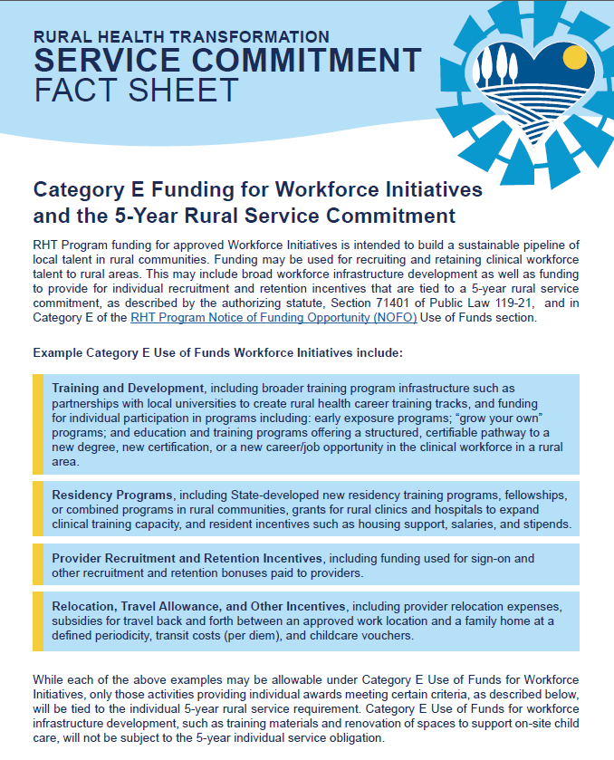

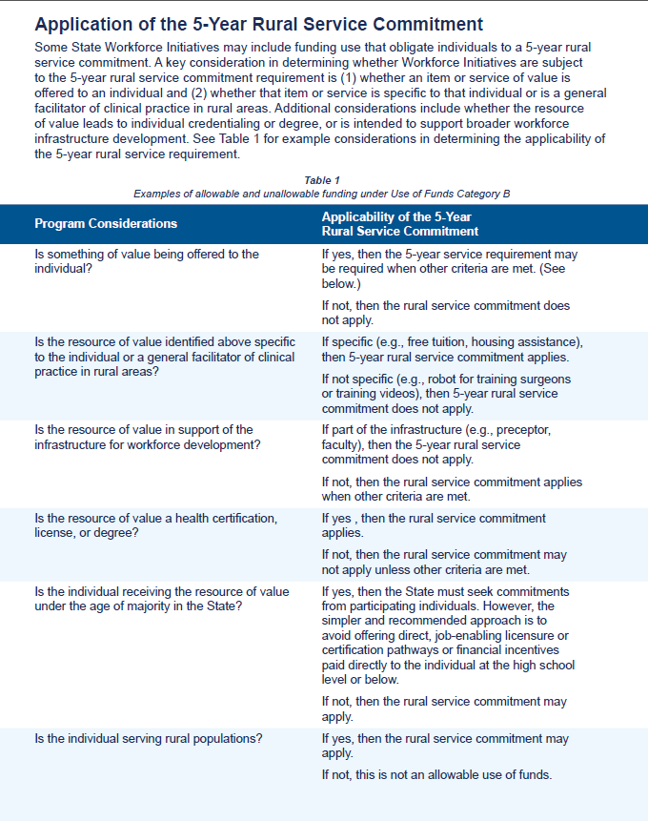

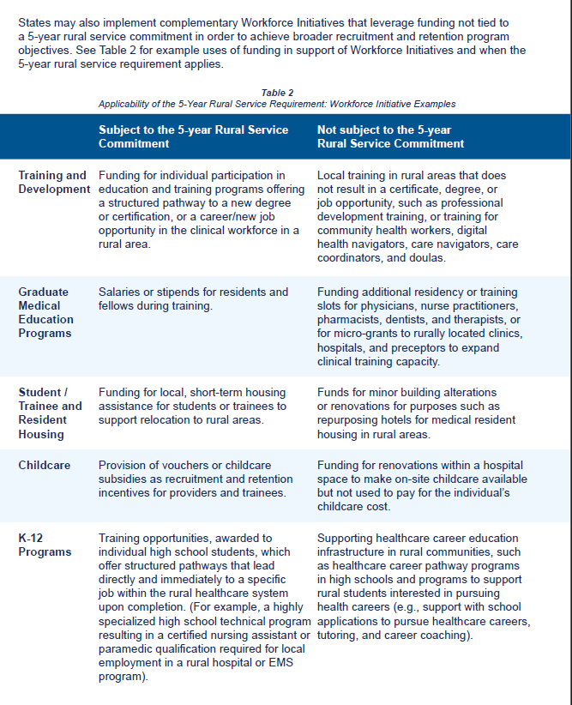

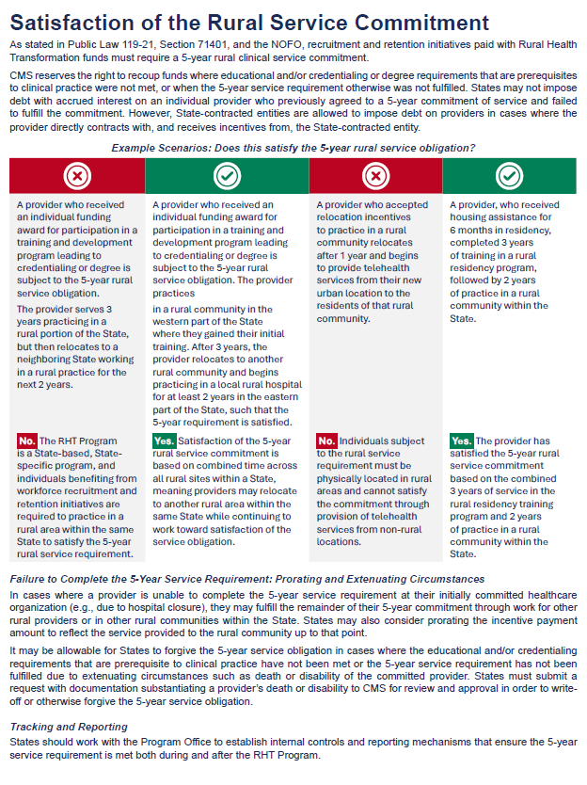

Appendix C. Sample Memorandum of Understanding
This is subject to change depending on terms and conditions of awards.

Agreement for RISE Funding
Between Association for Utah Community Health and [Organization Name]
This Memorandum of Understanding (“MOU”) is entered into and effective as of October 1, 2026 (the “Effective Date”), by and between Association for Utah Community Health, a Utah nonprofit corporation and Primary Care Association (“AUCH”), and [Organization Name] (“Subawardee”). AUCH and Subawardee may be referred to collectively as the “Parties” or individually as a “Party.”

1. Purpose
The purpose of this MOU is to document the Parties’ understanding regarding AUCH’s subaward of Rural Health Transformation Program (RHTP) funds to [Organization Name] through the Utah RISE 2.5 Recruit & Retain Initiative. The initiative is intended to support eligible Tier 2 organizations in recruiting and retaining eligible clinical staff serving rural Utah communities.

2. Background
The RISE 2.5 Recruit & Retain Initiative is administered by AUCH under Utah Department of Health and Human Services (UDHHS) RHTP. [Organization Name] has been identified as an eligible Tier 2 Subawardee and submitted an application to support approved recruitment and retention activities for eligible clinical staff who provide services in rural Utah counties.

The Parties agree to collaborate on the distribution, tracking, reporting, and documentation of RISE funding in accordance with applicable UDHHS, CMS, HHS, and AUCH requirements.

3. AUCH Responsibilities
AUCH agrees to:
- Maintain and adhere to an agreement with UDHHS that outlines the terms of AUCH’s participation in the distribution of RISE funding, if applicable;
- Receive and safeguard RISE funding for prompt distribution;
- Provide [Organization Name] with funding in the amount of [Funding Amount], subject to the availability of CMS/UDHHS funds, satisfactory performance, compliance with program requirements, and the terms and conditions of any applicable Notice of Award, subaward agreement, program directive, and/or written guidance issued by AUCH, UDHHS, CMS, or HHS;
- Distribute funding to [Organization Name] based on the approved application, approved budget, applicable award terms, and terms of participation;
- Complete and submit timely required reports to UDHHS and/or other required entities regarding distribution of RISE funding and recruitment/retention benchmarks;
- Compile and maintain success stories related to the use and impact of RISE funding; and
- Assist [Organization Name], as requested and as feasible, in distributing and tracking funding and recruitment/retention benchmarks.

4. [Organization Name] Responsibilities
[Organization Name] agrees to:
- Receive and distribute funding according to the approved application, approved budget, applicable award terms, and terms of participation;
- Use funds only for approved RISE 2.5 Recruit & Retain activities described in its application, approved budget, and any written approval issued by AUCH;
- Use funds only at RHTP-approved eligible sites identified in the approved application, approved eligible site list, or other written approval issued by AUCH, and only for allowable recruitment and retention strategies that directly support eligible clinical staff serving rural Utah communities;
- Not use funds to support staff, services, activities, costs, or operations at any site not identified as an AUCH-approved eligible site, unless AUCH provides prior written approval;
- Track and document the distribution of funding and collect information on recruitment and retention benchmarks;
- Complete and submit timely reports to AUCH regarding funding distribution, recruitment/retention benchmarks, and other required metrics;
- Promptly notify AUCH of any concerns regarding this MOU or challenges with distribution, recruitment/retention, reporting, eligibility, compliance, or repayment;
- Timely share success stories with AUCH related to the use and impact of RISE funding; employees’ identities may be kept confidential when appropriate;
- Verify and document that each supported clinical staff member meets applicable eligibility requirements before funds are distributed, including role eligibility, rural Utah service location, employment or contracted status, and direct patient care requirements, including providing a minimum of 15 hours of direct patient care per week when required;
- Verify and document the AUCH-approved eligible site where each supported clinical staff member provides services and ensure that RISE 2.5 funds are tied only to eligible clinical staff serving approved eligible sites;
- Maintain documentation sufficient to demonstrate eligibility, allowable use of funds, distribution of funds, and alignment with the approved application and budget;
- For any incentive or support subject to a required five-year rural Utah service commitment, incorporate the required service commitment, repayment, and proration language into applicable employment agreements, incentive agreements, offer letters, contract amendments, or other enforceable written agreements before distributing incentive funds;
- Ensure that affected clinical staff understand the service commitment begins from the date the last incentive is received, unless otherwise directed by AUCH or applicable program guidance;
- Notify AUCH within thirty (30) days if any clinical staff member receiving funds subject to a service commitment separates from employment, reduces hours below applicable eligibility requirements, changes role or service location in a way that may affect eligibility, or otherwise fails to complete a required commitment;
- If repayment or proration is required, cooperate with AUCH to calculate, document, and recoup funds within six (6) months of the triggering event, unless otherwise approved in writing by AUCH;
- Comply with all reporting, monitoring, site visit, and record-retention requirements established by AUCH, UDHHS, CMS, HHS, and applicable federal award requirements; and
- Maintain financial, payroll, personnel, incentive, service commitment, repayment, eligibility, and other supporting records and make such records available upon request to support monitoring, audit, evaluation, and closeout activities.

5. Payment and Invoicing
[Organization Name] shall submit invoices and supporting documentation to AUCH in accordance with AUCH instructions and any applicable award terms. AUCH shall make payments for allowable, approved costs up to [Funding Amount], subject to receipt of complete and accurate documentation, continued eligibility, satisfactory performance, and availability of funds.
AUCH will disburse funds according to the timeline and payment process established by AUCH and communicated to [Organization Name]. No additional expenses, fees, or reimbursements shall be due unless approved in advance in writing by AUCH.

If [Organization Name] terminates participation or otherwise ceases participation before all funds allocated for the year have been distributed, [Organization Name] agrees to return any undistributed funding allocated for that year, unless otherwise directed in writing by AUCH.

6. Reporting, Monitoring, and Record Retention
[Organization Name] agrees to cooperate with AUCH, UDHHS, CMS, and HHS monitoring, reporting, evaluation, and site-visit requirements. Required reporting may include quarterly and annual workforce and financial metrics, documentation of incentives issued, eligible clinical staff supported, AUCH-approved eligible site served, recruitment and retention outcomes, active service commitments, departures before completion of a required commitment, repayment or proration events, and success stories or other information needed to document program progress.

[Organization Name] shall maintain all supporting documentation, including financial records, staff eligibility documentation, approved eligible site documentation, service commitment agreements, repayment documentation, and other records necessary to demonstrate compliance with federal, state, and AUCH requirements.
[Organization Name] shall submit, at minimum, information required by AUCH for every staff member receiving RISE funding, which may include name, title or staff type, AUCH-approved eligible site served, amount of funding received, uses for funding, and date disbursed, along with any additional information required by AUCH, UDHHS, CMS, HHS, or applicable award terms.

7. Compliance
[Organization Name] affirms that it is not debarred, suspended, proposed for debarment, declared ineligible, voluntarily excluded, or otherwise excluded from participation in federal programs or from receiving federal funds. [Organization Name] agrees to comply with all applicable federal and state laws, regulations, and program requirements, including 2 CFR Part 200, the Rural Health Transformation Program Notice of Funding Opportunity, the Notice of Award, RHTP Program Directives, and applicable AUCH guidance.

[Organization Name] shall acknowledge federal funding support in public-facing materials as required by the Stevens Amendment and shall promptly report any compliance concerns, questioned costs, use of funds outside RHTP-approved eligible sites, or circumstances that may affect continued eligibility for funding.

8. Term and Termination
This MOU shall begin on October 1, 2026 and end on September 30, 2027, unless amended or terminated earlier in writing by the Parties or as required by applicable funding terms and conditions.

Continuation or renewal beyond the initial term is dependent wholly on the availability and receipt of continued funding from UDHHS/CMS/HHS and UDHHS’ ongoing willingness to maintain an agreement with AUCH, if applicable. If AUCH requires advance notice of [Organization Name]’s intent to cease participation in order to reallocate funding to other eligible organizations, [Organization Name] agrees to provide such notice by the deadline established by AUCH.

If [Organization Name] fails to provide timely required reporting on funding distribution, recruitment/retention benchmarks, or other required metrics, AUCH may provide written notice to [Organization Name]. If [Organization Name] fails to respond to the notice within ten (10) business days, AUCH may terminate this MOU immediately. If this occurs, [Organization Name] agrees to repay AUCH any undistributed funding for that year’s term within thirty (30) days.

If UDHHS, CMS, HHS, or another applicable funding authority removes AUCH from participation in the RISE funding or otherwise terminates or materially changes AUCH’s authority to distribute funds, AUCH will notify [Organization Name] and take steps consistent with applicable award terms, including final reporting and disposition of remaining funds.

Notwithstanding the above, if AUCH or [Organization Name] becomes suspended, debarred, proposed for debarment, declared ineligible, or voluntarily excluded from the award of contracts or receipt of federal funds by any federal agency or department, this MOU shall terminate immediately.

9. Notices
All notices and other communications in connection with this MOU shall be in writing and shall be considered given when sent by email to the email address of the recipient known to the person giving notice, unless another method is required by applicable award terms or agreed to in writing by the Parties.

Notification shall be given to:
AUCH
Alan Pruhs, Executive Director
Association for Utah Community Health
5217 South State Street, Ste. 201
Murray, UT 84107
Phone: (801) 716-4601
Email: alan@auch.org

[Organization Name]
Name: ______________________________
Title: _______________________________
Address: ____________________________
City, State, Zip: ______________________
Phone: ______________________________
Email: _______________________________

10. Amendments
This MOU may be amended in writing only with the signature of both Parties.

11. Indemnification
Each Party is liable for, indemnifies, and holds the other Party harmless from any claim, lawsuit, action, and legal expense relating to the indemnifying Party’s negligent act or omission, intentional misconduct, misrepresentation, or breach of this MOU.

12. Limitation of Liability
In recognition of the overall risks and benefits of this work to AUCH and [Organization Name], both Parties agree that neither Party will be liable to the other Party for special, consequential, exemplary, punitive, incidental, or other indirect damages, losses, or expenses related to the RISE funding.

13. Governing Law
This MOU shall be governed by and construed in accordance with the laws of the State of Utah.

14. Taxes
AUCH is not responsible for calculating, paying, withholding, reporting, or responding to any request regarding any taxes on RISE funding that is distributed by [Organization Name]. [Organization Name] and [Organization Name]’s employees or contractors bear the responsibility for any taxes, withholdings, or related obligations associated with funds distributed by [Organization Name].

15. No Partnership
Both Parties agree that this MOU creates no partnership, joint venture, employment relationship, or agency relationship beyond what is described in this MOU and any applicable attachments, award terms, or terms of participation.

16. Entire Agreement
This MOU and any attachments, incorporated award terms, written approvals, and terms of participation constitute the entire agreement between the Parties regarding the subject matter of this MOU. Both Parties agree that no oral or written prior agreement, representation, or conversation has any force or effect unless this MOU is amended as provided herein.

17. Signatures
IN WITNESS WHEREOF, the Parties have caused this MOU to be executed by their duly authorized representatives as of the Effective Date.

Association for Utah Community Health | [Organization Name]
By: ________________________________  Name: Alan Pruhs  Title: Executive Director  Date: ______________________________ | By: ________________________________  Name: ______________________________  Title: _______________________________  Date: ______________________________

Attachment A
[Agreement between AUCH and UDHHS, if applicable.]

Attachment B
Terms of participation
AUCH will disburse funds on the following timeline to Entity: TBD

Entity will submit the following information to AUCH for every staff member receiving RISE funding on TBD schedule. RISE 2.5 funds may be used only to support eligible clinical staff serving RHTP-approved eligible sites identified in the approved application, approved eligible site list, or other written approval issued by AUCH.

Name | Title/staff type | AUCH-approved eligible site served | Amount of funding rec’d | Uses for funding (list all) | Date disbursed

